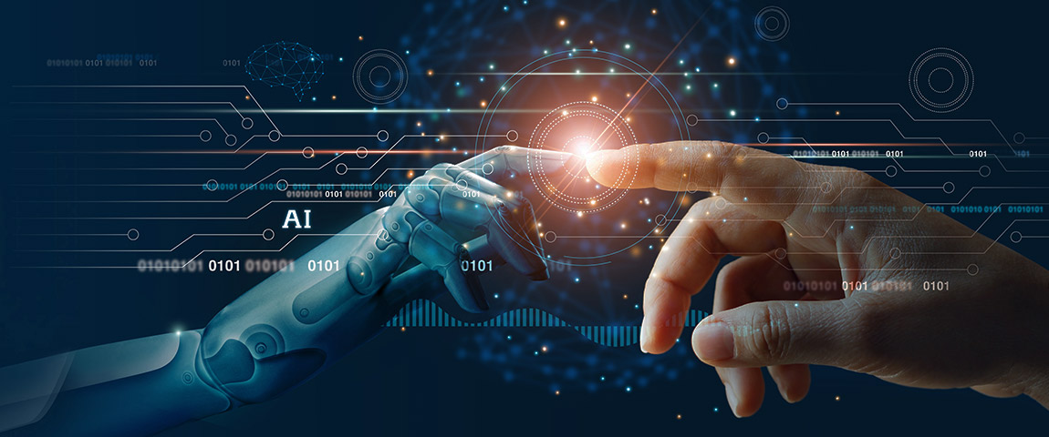
Essay: AI Should Augment Human Intelligence, Not Replace It
By (Name)

Student ID
Professor
Course
Institute Name
Date

Table of Contents
Introduction 1
System Thinking Theory 2
Global Commerce 3
Conclusion 5
References 7
Technology Section 8

Introduction
The current assignment has been prepared to conduct a critical analysis of the article of David De Cremer and Garry Kasparov where they have tried to emphasise that artificial intelligence AI should augment Human Intelligence, not replace it. Upon summarising this article, one can infer that the authors have tried to determine whether is it possible for intelligent robots to take the place of human workers in the workplace. However, the authors answered this question by stating that AI will not replace humans (De Cremer and Kasparov, 2021).
This is because humans and artificial intelligence augment each other and both have a lot to teach us about how to be better humans. In this case, the authors have argued that a question can be raised regarding whether or not human cognition and artificial intelligence can coexist and develop greater intellect. Throughout this article, Garry Kasparov, the great chess player, shares his unique take on the game (De Cremer and Kasparov, 2021). His experiments with computer aid began after he was defeated by IBM's Deep Blue. He was interested in how computer assistance affected the competitive edge of top-level chess players.
He realised that having the greatest players and the best programme were just secondary to having a system that was extraordinarily effective in its execution. The scientists came to the shocking conclusion that "weak human + machine + excellent process" was better to "strong human + machine + bad process" in terms of performance. Moreover, while studying how to integrate artificial intelligence into their organisations, the findings of the article have highlighted that CEOs must lower their expectations, make investments in bringing their teams together and fine-tuning their processes, and cultivate their own leadership characteristics (De Cremer and Kasparov, 2021).

System Thinking Theory
To determine whether human beings and AI technologies can co-exist with each other, system thinking theory can be used in order answer the question that was raised in the article of De Cremer and Kasparov (2021) that whether AI can augment human intelligence or not. Systems thinking theory provides a holistic approach to analysis that focuses on the interaction of a system's component parts and how systems function through time and within larger systems. Contrary to classical analysis, which investigates systems by dismantling them into their constituent pieces, the systems thinking method analyses systems holistically (Tani et al., 2018).
Systems thinking has been used to the study of medical, environmental, political, economic, human resource, and educational systems. Upon applying this theory on the article of De Cremer and Kasparov (2021), it can be inferred that rather than looking AI and human intelligence as separate elements, one should always consider them as highly integrated with each other, and they should always be analysed holistically. This is because through collaborative intelligence, humans and AI complement one another's strengths: the former's leadership, collaboration, creativity, and social talents, while the latter's speed, scalability, and quantitative capabilities (Abreu and Urze, 2016). This makes it mandatory for businesses to analyse them holistically and use them collaboratively to improve their performance. What comes naturally to humans (telling a joke, for example) may be difficult for computers, and what machines find easy (analysing terabytes of data) is almost impossible for humans. Thus, both kind of abilities are necessary for the organisations of today. Businesses must have a thorough grasp of how people complement technology, how robots supplement what humans do best, and how company systems may be adapted to suit the partnership in order to reap the most benefits from the cooperation. In order to survive as humans, people will be required to engage in several important tasks (Redmond and Alshawi, 2017).
For instance, it will be their responsibility to explain what happened when unexpected or disputed outcomes arise as a consequence of their activities and to guarantee that equipment is utilised correctly (by, for instance, preventing robots from harming humans). Because of the so-called "black-box" problem, human experts in the field are necessary to explain the behaviour of artificial intelligence to non-expert users. A practitioner in an evidence-based area such as law or medicine, for example, has to comprehend how an artificial intelligence analysed inputs in a phrase or a medical prescription in order to be effective in their profession (Tani et al., 2018). Additionally, insurers and law enforcement rely on explainers to understand why an autonomous vehicle performed actions that resulted in an accident—or did not result in an accident—and to ascertain the cause of the event.
Understandable explanations are becoming more crucial, even in regulated businesses where the output of a machine may be questioned as unfair, illegal, or just erroneous. This again mandates that both human intelligence and AI should be looked holistically as per the concepts of the system thinking theory in order to capitalise on their benefits and understand how they can be integrated with each other for the benefit of the businesses, as well as the consumers (Abreu and Urze, 2016).

Global Commerce
With a focus on global trade, the theory of Global Commerce examines the exchange of goods, services, data, and currencies on a business and non-profit basis throughout the globe. This interdisciplinary major examines the relationship between globalisation and markets, trade, and organisational cultures. Since the theory of global commerce emphasise and promote modern ways of trade and commerce, it can also be applied to understand the relationship between human and artificial intelligence as described by De Cremer and Kasparov (2021) within their article.
An example of this can be taken from the article of Paschen et al. (2020) who have provided a detailed explanation on how collaborative intelligence will help in improving business-to-business sales process. In this regard, the authors have stated that a transformation in the business-to-business (B2B) sales process is on the horizon, thanks to advances in artificial intelligence (AI) under global commerce. The nature of human labour, and in particular the nature of human cognition and decision-making, will experience significant changes in the near future. AI will help B2B salespeople succeed, and it may eventually take over some of the tasks now performed by humans.
AI and business-to-business sales are two topics on which CEOs are unclear about the impact the technology will have on the process, as well as the function salespeople will play in an AI-enabled sales funnel (Vaki, 2016). When human judgement and oversight are necessary for AI adoption, this knowledge becomes even more critical to have on hand. From this data, it is possible to draw reasonable inferences about the value added by artificial intelligence systems at each level of the sales funnel, as well as the role played by human cognition and decision-making at each stage of an AI-enabled sales funnel. However, although artificial intelligence (AI) may have a positive impact on the sales process, managers must be prepared to foresee and plan for changes in customer behaviour (Paschen et al., 2020). The customer experience will be altered by artificial intelligence, and customers will need to be educated about the AI-enabled sales funnel before they can embrace it. Artificial intelligence (AI) is a more effective means for businesses to produce greater services and sales experiences than they have ever been before.
However, customers should not see AI as a way for businesses to do less for them. Certain customers may have misgivings regarding the use of artificial intelligence to aid them in their work. In these situations, a uniform technique of serving these cautious customers will be required that will again makes it necessary for businesses to rely on human intelligence, which will again benefit global commerce (Krosinsky, 2016).

Conclusion
By considering the above analyses, it can be concluded that collaborative intelligence will serve as the foundation for the workplace of the future. In order to succeed in today's constantly changing environment, a company must use collaborative intelligence. When it comes to reaping the full advantages of cooperation, it is vital for organisations to understand how people and machines can work together most effectively. It can also be concluded that it will become necessary for companies to experiment with fresh ways and methodologies in order to complete the bulk of user-machine interaction activities (for example, while creating a chatbot and train that chatbot to provide better customer service). The whole promise of artificial intelligence will be squandered if organisations deploy it just to replace workers. As a result, this strategy is doomed from the start.
Those that embrace collaborative intelligence will be the leaders of the future, revolutionising their operations, markets, industries, and, most importantly, their workforces. However, it can also be concluded that one of the most important aspects of a highly intelligent future of work will be the expansion of the workforce to include both humans and robots, with the objective of boosting humanity and well-being while also increasing job efficiency. As a consequence, while augmented intelligence is collaborative in nature, it will become self-evident that it is a cooperative endeavour for the benefit of people. Moreover, it is possible that any non-human colleague will be regarded with suspicion and unfavourable expectations, prompting people to suppress information and avoid working with machines altogether in the future. To address this problem, leaders will need to be trained on how to deal with dysfunctional relationships within the team, as well as how to recognise the truth and ramifications of erroneous views held by members of the team, in order to effectively lead their teams.

References
Abreu, A. and Urze, P., 2016. System thinking shaping innovation ecosystems. Open Engineering, 6(1).
De Cremer, D. and Kasparov, G., 2021. AI should augment human intelligence, not replace it. Harvard Business Review.
Krosinsky, C., 2016. The main segments of global commerce and what’s needed. In Sustainable Investing (pp. 161-162). Routledge.
Paschen, J., Wilson, M. and Ferreira, J.J., 2020. Collaborative intelligence: How human and artificial intelligence create value along the B2B sales funnel. Business Horizons, 63(3), pp.403-414.
Redmond, A.M. and Alshawi, M., 2017, June. Applying System Science and System Thinking Techniques to BIM Management. In 2017 10th International Conference on Developments in eSystems Engineering (DeSE) (pp. 3-8). IEEE.
Tani, M., Papaluca, O. and Sasso, P., 2018. The system thinking perspective in the open-innovation research: A systematic review. Journal of Open Innovation: Technology, Market, and Complexity, 4(3), p.38.
Vaki, F., 2016. Adam Smith and Immanuel Kant as critics of empire: International trade companies and global commerce versus jus commercii. In The Adam Smith Review: Volume 9 (pp. 27-36). Routledge.

Technology Section
For conducting my search and completing my assignments, the technology that facilitated me the most was my laptop and the internet. This is because by using my laptop, I was able to access different software tools like Microsoft Word where I was able to create my assignments in an appropriate format and by maintaining quality. On the other hand, to search relevant data or information for completing my assignment, the technology of internet also played a crucial role in facilitating me, especially in terms of clarifying my queries that I had regarding my assignment. Here by using internet and popular search engine websites like Google (and Google Scholar), I was able to find relevant data for completing my assignment. This also enabled me to conduct critical analysis on my current assignment where I have given a detailed discussion on the article of De Cremer and Kasparov (2021) related to AI and human intelligence collaboration. Similarly, and as stated earlier, the software application that I used for completing my essay was Microsoft Word. Besides, utilising this tool, I also used popular referencing tools like Zotero in order to provide citations and bibliography of the articles that I have utilised in completing my assignment. These tools also assisted me greatly in completing my work on time. This is because if I have completed my essay in the form of traditional hand-written assignment, then I would have taken a lot of time to finish it since my writing speed is slow in comparison to my typing speed. Moreover, without the use of Zotero and website like Google Scholar, I would have also faced difficulty in finding the right articles for completing my essay assignment.

