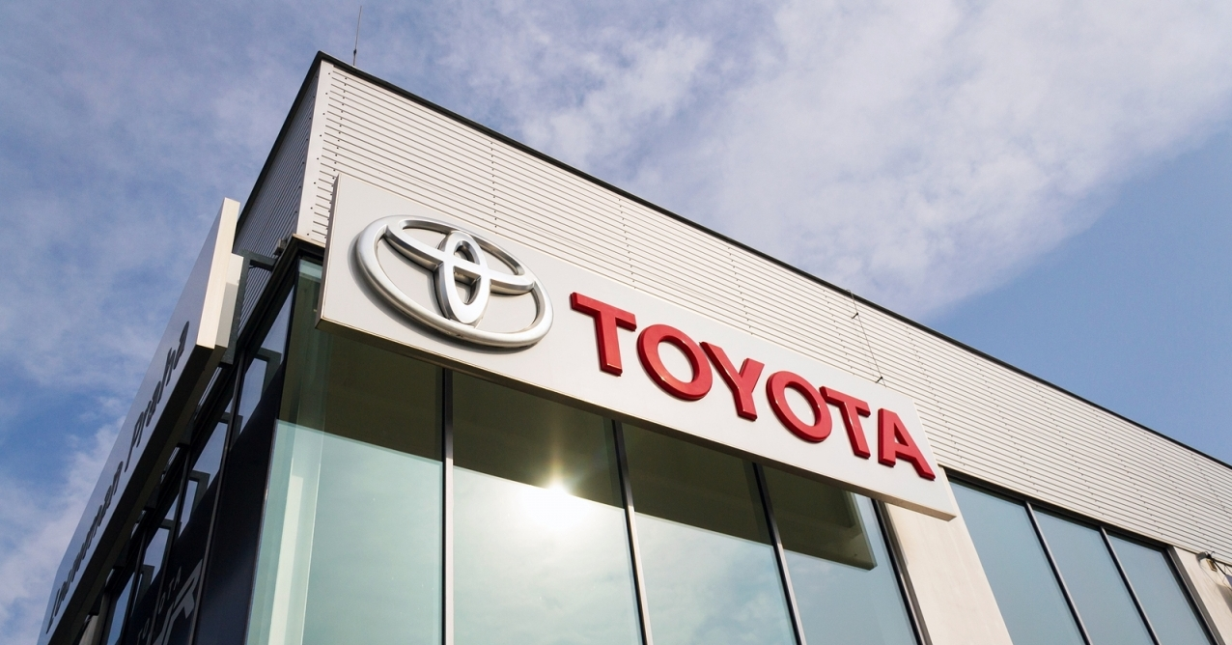
Business Contexts and its Management (Industry Trend Analysis and Client Report – Toyota Motor Corporation)
By (Name)

The Name of the Class (Course)
Professor (Tutor)
The Name of the School (University)
The City and State where it is located
Date

Table of Contents
Part 1: Industry Trend Report 1
1.0 Introduction 1
Background 1
Scope 1
1.1 Task One – Identifying Issues 1
1.2 Task One – Analysis of External and Internal Environment 2
Components of Industry Sector (External Environment) 2
Analysis of the Sector 3
1.3 Task Two – Internal Environment Competence Analysis 6
Internal Factor Analysis – VRIO Framework 6
2.4 Task Three – The Impact and Influence of Change and Culture 7
Impact of Implementing Change (Kurt Lewin’s Model) 7
Influence of Culture on Management Decision 8
Effectiveness of Operational Functions – TQM 8
Stakeholder Analysis and Landscape 9
Summary 10
Part 2: Client Report 11
2.5 Task Four – Strategic Planning 11
Benefits of Planning When Formulating Strategy 11
Strategy Recommendation (PDCA Cycle) 11
Conclusion 12
References 13

Part 1: Industry Trend Report

1.0 Introduction

Background
The outbreak of the Covid-19 pandemic has impacted almost every industry adversely around the world and this is also true for the automotive industry. This is because, before the Covid-19 pandemic, the sales of automobiles globally were noted to be around 80 million units in 2017. However, after the outbreak of coronavirus, and the resulting disruptions within the operations of automobile companies like Toyota, a significant decline in the profits of the companies was observed and it has been forecasted that the global sales of automobile companies will further decrease in 2021 to just under 70 million units (Wagner, 2021).

Scope
To address the challenges and problems that have been caused by the Covid-19, the case study analyses under this report have specifically focused on devising appropriate business strategies or post-pandemic strategic plan for Toyota to help the company increase its sales and profitability. The report has also analysed the industry trends and potential opportunities for Toyota to expand its businesses under the market of electric vehicles where the demand from the customers is expected to increase in the future significantly (Wagner, 2021).

1.1 Task One – Identifying Issues
After the outbreak of coronavirus and its rapid spread all over the world, many automobile companies like Toyota were compelled to temporarily shut down their operations due to the lockdown that was imposed by the governments/regulatory authorities in different countries (Hoeft, 2021). The supply chain and operations of these companies were also adversely affected by this pandemic, which as a result also forced some of the automotive companies to make their employees redundant (Belhadi et al., 2021).
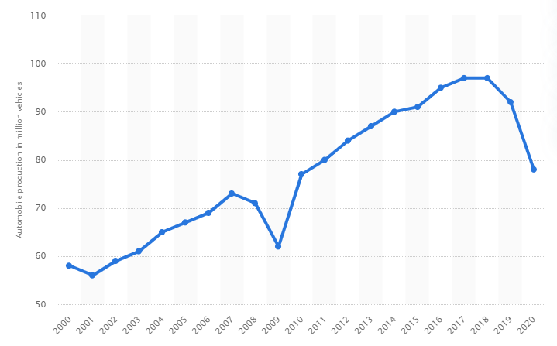
The overall impact of the Covid-19 pandemic was highly negative for the automobile industry since worldwide automobile production was observed to experience a sharp decline from 92 million vehicles (that was recorded in 2019) to 78 million vehicles in 2020 (Statista Research Department, 2021) (see figure 1). Thus, it is important for companies like Toyota to devise the right business strategies that enable them to recover from this pandemic and improve their performance and profitability.

Figure 1: Estimated worldwide automobile production from 2000 to 2020 (in million vehicles) – Source: Statista Research Department (2021)

1.2 Task One – Analysis of External and Internal Environment

Components of Industry Sector (External Environment)
Upon analysing the external environment or components of the automotive industry, it can be inferred that it is highly competitive as there are many automobile companies like Ford, General Motors, Tesla, Honda, etc., that are manufacturing the same types of vehicles (i.e., internal combustion engine, hybrid, and electric vehicles) which are produced by Toyota. This means that customers have a low switching cost since there are many options for them to purchase their vehicles (Rao, 2017). Similarly, the income of the customers under the countries where automobile companies like Toyota operate can also be considered as another important component of the industry (Dhanabalan et al., 2018).
This is because, after the outbreak of the coronavirus, a significant number of people were unemployed in different countries as organizations were forced to halt their production and close their businesses temporarily to prevent the spread of this virus. This, as a result, compelled many companies to make their employees redundant, causing a significant decline in both the income and demand of the people for goods and services that also include expensive products like vehicles (Han et al., 2020).

Analysis of the Sector

Market Size
By analysing the market size of the global automobile industry, it can be stated that the industry has reached its saturation point due to high competition, especially within the market of commercial and passenger vehicles (Rao, 2017). However, despite this saturation, including the problems created by the Covid-19 pandemic, it is still expected that the total available market (TAM) in the global automobile industry will increase to around US$ 25,719 million in 2025 from US$ 20,321 million which was recorded in 2020 (PR Newswire, 2020).
Whereas, the value or size of the serviceable available market (SAM) under TAM that Toyota targets in its geographic reach (i.e., market share) is around US$ 8,692,168 as of 2020 (Roberts, 2021). Whereas, the Serviceable Obtainable Market (SOM), which is related to selling electric vehicles, that Toyota can capture in the coming years under SAM is approximately US$ 803 billion (Wagner, 2021). This is because it is expected that in 2027, the market size of electric vehicles will reach US$ 803 billion, which in turn, will offer an opportunity to the company to increase its sales and profitability.

Stage in Economic Cycle (Business Cycle Analysis)
Upon conducting a business cycle analysis for Toyota, one can infer that currently the markets or countries where Toyota is conducting its operations are going through the trough and recovery phases. This is because in several countries, like India (Nair, 2021), where Toyota sells its passenger and commercial cars, both the GDP level, as well as the demand for expensive products (like vehicles) have been noted to decline and reach their lowest points. This is because, in some countries, the cases of Covid-19, including the resulting fatalities of people are still rising, which as a result, has compelled the governments in these countries to maintain their decision related to imposing a complete lockdown (Coibion et al., 2020).
This, in turn, has made it difficult for many businesses in these countries to resume their operations by reopening their workplaces, which as a result, has also compelled them to make their employees redundant to save their cost since they are not able to increase their production and output. These high cases of Covid-19 were also the reason behind the increase in the unemployment rate around the world from 5.373 percent that was recorded in 2019 to 6.471 percent in 2020 (World Bank, 2021) (see figure 2).
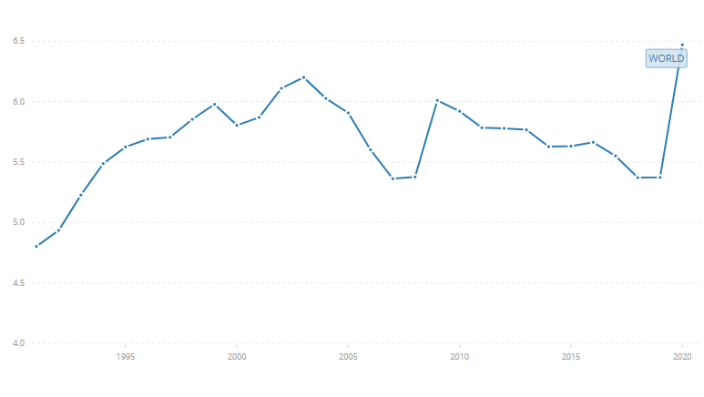
However, in some countries (like China) where the cases of Covid-19 have reduced and where the governments have allowed the businesses to resume their operations, it is expected that the economies of these countries will recover (Wang and Zhang, 2021). This, as a result, will also increase both the employment level, as well as the demand of the people in these countries for expensive products like vehicles that are sold by Toyota. Thus, it is important for Toyota to sell its expensive vehicles (including electric vehicles) under those countries that are going through the recovery phase of their economic cycle, and sell less expensive cars under those economies that are still going through the trough stage.
Figure 2: Unemployment, total (% of total labour force) (modelled ILO estimate) – World Bank (2021)

Market Opportunities
As stated earlier, there is an opportunity for Toyota to expand its operations under the market of electric vehicles. This is because, in the coming years, the demand for electric cars is expected to increase, primarily due to the changing preferences of the people with regard to avoid the purchase of those vehicles having traditional internal combustion engine, which are known for increasing pollution level and causing scarcity of non-renewable resources like fossil fuel (Moon et al., 2018).
In this regard, there is also an opportunity for Toyota to utilize the blue ocean strategy by entering the market of self-driving cars or unmanned vehicles where it can face less competition (Zakharenko, 2016). This is because only a few automobile companies are manufacturing unmanned vehicles and these cars are still sold in fewer quantities commercially. Thus, by using the blue ocean strategy to exploit this market, Toyota can gain benefits by increasing its sales and profits successfully (Zhao et al., 2018).

1.3 Task Two – Internal Environment Competence Analysis

Internal Factor Analysis – VRIO Framework
To analyse the internal factors of Toyota in order to determine its competitiveness, the VRIO framework has been used in this section of the report (see below figure). The framework of VRIO examines the capabilities and resources of a company with respect to their value, organization, rarity, and imitability that, in turn, assist in giving the organization a sustainable competitive advantage (Herder, 2021). When it comes to Toyota, its resources, technologies, as well as its employees indeed play a crucial role in adding value for the customers.
This is because, Toyota is known for manufacturing different types of commercial and passenger vehicles that give safety, comfort, and value for money to its target customers. Moreover, the resources of Toyota are also rare, especially related to its usage of Toyota Production System, as well as R&D technologies, which in turn, has allowed the company to produce different types of vehicles as per the specifications and requirements of its customers (Smith, 2019).
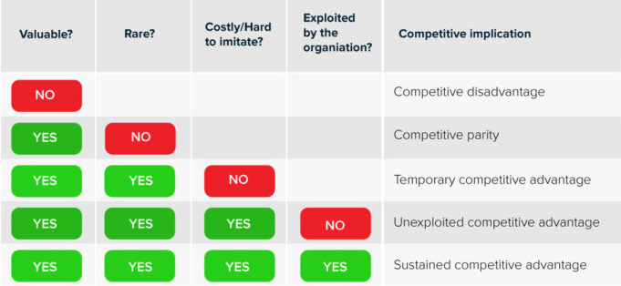
Furthermore, the resources, especially the knowledge and skills of the employees of Toyota are also cost to imitate by the competitors. This is because it would take a significant amount of time for Toyota’s competitors to acquire the same resources or knowledge that the company is using to produce its commercial vehicles. In addition to this, Toyota also possess organized management systems like Kaizen, Just-in-Time, Jidoka, etc., that have helped the company to improve the quality of its vehicles and efficiency of its production processes, leading to enhanced organizational performance (Chiarini et al., 2018). Thus, the findings of both the external and internal analysis of Toyota are clearly depicting that there is an opportunity for the company to utilize its existing competencies, resources, and capabilities to manufacture electric vehicles (including unmanned cars) to improve its profitability after the Covid-19 pandemic.
Figure 3: VRIO Framework – Source: Herder (2021)

2.4 Task Three – The Impact and Influence of Change and Culture

Impact of Implementing Change (Kurt Lewin’s Model)
In this section, Kurt Lewin’s model has been used to explain how Toyota can increase its production of electric vehicles so that it can capitalize on the growing demand for these cars in the coming years (Hussain et al., 2018). In this regard, the company will have to prepare its workers (i.e., unfreeze stage) by providing them training related to manufacturing electric cars, including unmanned vehicles.
After this, Toyota will also have to address the uncertainty of its employees and help them to accept the change (i.e., change phase) related to increasing its reliance on electric vehicles. For this purpose, the company can reward its employees for accomplishing their goals and accepting the change as promptly as possible. Finally, Toyota will also need to ensure that the new working methods related to manufacturing electric cars are followed by employees in the long run (i.e., refreeze stage) (Enyedi, 2018).

Influence of Culture on Management Decision
To take appropriate management decisions related to recovering from the Covid-19 pandemic by increasing the production of electric cars, Toyota will have to adopt a task culture which has been explained under the theory of Charles Handy as action and task-oriented culture (Handy, 1976). By adopting this culture, the company will be able to become more responsive since task culture promotes the empowerment of employees, as well as teamwork. This as a result will allow Toyota to become more responsive, take effective actions, solve problems, and achieve its goals related to producing novel electric vehicles to meet the demand of its customers, successfully.

Effectiveness of Operational Functions – TQM
To manage quality, Toyota utilizes the approach of “Kaizen” which means continuous improvements and it also follows the concept of “customer first”. This, as a result, has enabled Toyota to manufacture its passenger vehicles by meeting both the needs and expectations of its customers successfully (Morgan and Liker, 2020). Thus, the same effectiveness in operational functions can also be maintained by Toyota for producing electric vehicles where it can also involve its employees to manufacture unmanned vehicles.

Stakeholder Analysis and Landscape
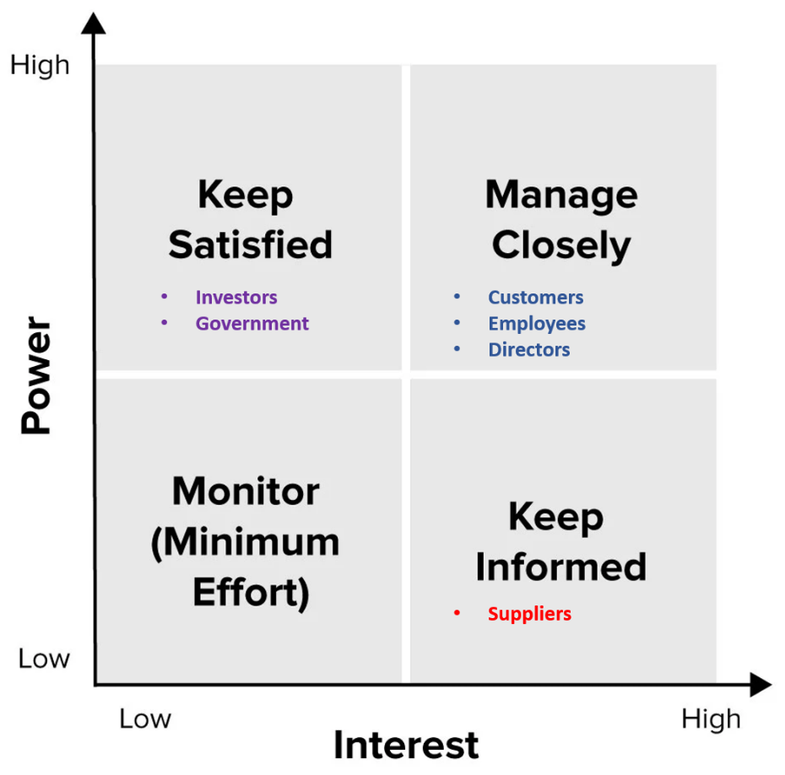
The internal stakeholders of Toyota can include its employees, investors, directors, and managers. While the external stakeholders of the company can include its customers, government, and suppliers (Rowland, 2017). The stakeholder map has also been highlighted for Toyota in the below figure. As indicated by the figure, Toyota needs to keep its customers, directors, and employees engaged since they have a high influence on the performance of the company.

Figure 4: Stakeholder Map
They are also important for Toyota to accomplish its organizational goals related to improving its performance after the Covid-19 pandemic. Whereas, Toyota also needs to keep its suppliers informed about its decisions as they have low power but high interest under the company’s operations. While Toyota needs to keep its investors and government satisfied since they have high power with regard to helping the company in attaining necessary financial and non-financial support for producing electric vehicles.

Summary
From the above-conducted analyses, it can be concluded that despite the problems that have been caused by the Covid-19 outbreak, there is still an opportunity for Toyota to increase its profits by manufacturing and selling electric vehicles. In this regard, the company can use its existing capabilities, resources, and technologies and promote a task-oriented culture to meet the demand of the customers for electric vehicles, which is expected to increase in the coming years.

Part 2: Client Report

2.5 Task Four – Strategic Planning

Benefits of Planning When Formulating Strategy
There are several benefits that organisations like Toyota can obtain by creating appropriate strategic plans before formulating their strategies. For instance, one such benefit of the strategic plan is related to assisting organizations in defining their directions and establishing realistic goals and objectives in line with the vision and mission of their companies (Arend et al., 2017). Moreover, strategic plans also help employees to know what they are required to do, which in turn, enables them to work effectively to enhance the operational efficiency of their companies. Furthermore, continuous improvements in strategic plans can also benefit businesses like Toyota to become more proactive rather than reactive while adapting to changing market conditions (Bryson and Edwards, 2017).

Strategy Recommendation (PDCA Cycle)
To create a post-pandemic strategic plan in order to recommend an effective business strategy for Toyota, PDCA Cycle (i.e., plan-do-check-act) has been used in this section of the report (Johnson, 2016). The details of the plan are provided below:
- Plan: As stated earlier, there is an opportunity for Toyota to capitalize on the rising demand for electric vehicles for which it can plan to change its working process, perhaps by reducing its reliance on those vehicles that are made by using internal combustion engines. This can also include creating unmanned vehicles.
- Do: To implement the plan, Toyota can utilize its existing technologies and production processes to manufacture electric vehicles. This can also include the provision of training to the employees so that they become more familiar with producing electric vehicles (including self-driving cars).
- Check: In this stage, Toyota can check the performance of its strategies related to manufacturing electric vehicles and self-driving cars by measuring its sales revenues and profitability (Singh et al., 2016).
- Act: Finally, by assessing its performance, Toyota can also take appropriate actions to further improve its strategy and make possible corrections in its plan. An example of this can include changing the pricing strategy of the electric vehicles (perhaps by decreasing them) to increase the sales revenues and profits of the company better than competitors.

Conclusion
By considering the above analyses, it can be concluded that before devising the right strategy, Toyota will have to create an effective strategic plan to provide appropriate direction to the employees and help the business in achieving its goals related to capitalizing on the potential increase under the demand of electric vehicles in the future. Moreover, by devising an effective strategic plan and making continuous improvement within its strategies in response to the changing market condition, Toyota can also become more successful in addressing the challenges and recovering from the damages that the Covid-19 pandemic has caused for the entire automotive industry.

References
Arend, R.J., Zhao, Y.L., Song, M. and Im, S., 2017. Strategic planning as a complex and enabling managerial tool. Strategic Management Journal, 38(8), pp.1741-1752.
Belhadi, A., Kamble, S., Jabbour, C.J.C., Gunasekaran, A., Ndubisi, N.O. and Venkatesh, M., 2021. Manufacturing and service supply chain resilience to the COVID-19 outbreak: Lessons learned from the automobile and airline industries. Technological Forecasting and Social Change, 163, p.120447.
Bryson, J. and Edwards, L.H., 2017. Strategic planning in the public sector. In Oxford Research Encyclopedia of Business and Management.
Chiarini, A., Baccarani, C. and Mascherpa, V., 2018. Lean production, Toyota production system and kaizen philosophy. The TQM Journal.
Coibion, O., Gorodnichenko, Y. and Weber, M., 2020. The cost of the covid-19 crisis: Lockdowns, macroeconomic expectations, and consumer spending (No. w27141). National Bureau of Economic Research.
Dhanabalan, T., Subha, K., Shanthi, R. and Sathish, A., 2018. Factors influencing consumers’ car purchasing decision in Indian automobile industry. International Journal of Mechanical Engineering and Technology, 9(10), pp.53-63.
Enyedi, S., 2018, May. Electric cars—Challenges and trends. In 2018 IEEE International Conference on Automation, Quality and Testing, Robotics (AQTR) (pp. 1-8). IEEE.
Han, J., Meyer, B.D. and Sullivan, J.X., 2020. Income and Poverty in the COVID-19 Pandemic (No. w27729). National Bureau of Economic Research.
Handy, C.B., 1976. So you want to change your organisation? Then first identify its culture. Management education and development, 7(2), pp.67-84.
Herder, S., 2021. Value Chain Analysis Modeling - VRIO Framework & Strategy. [online] CBX Software. Available at: <https://www.cbxsoftware.com/value-chain-analysis-models/> [Accessed 22 May 2021].
Hoeft, F., 2021. The case of sales in the automotive industry during the COVID‐19 pandemic. Strategic Change, 30(2), pp.117-125.
Hussain, S.T., Lei, S., Akram, T., Haider, M.J., Hussain, S.H. and Ali, M., 2018. Kurt Lewin's change model: A critical review of the role of leadership and employee involvement in organizational change. Journal of Innovation & Knowledge, 3(3), pp.123-127.
Johnson, C.N., 2016. The benefits of PDCA. Quality Progress, 49(1), p.45.
Moon, H., Park, S.Y., Jeong, C. and Lee, J., 2018. Forecasting electricity demand of electric vehicles by analyzing consumers’ charging patterns. Transportation Research Part D: Transport and Environment, 62, pp.64-79.
Morgan, J. and Liker, J.K., 2020. The Toyota product development system: integrating people, process, and technology. CRC Press.
Nair, K.S., 2021. The COVID-19 Pandemic and the Public Health System Challenges in India. Journal of Pharmaceutical Research International, pp.169-182.
PR Newswire, 2020. The global automotive motors market size is projected to grow from USD 20,321 million in 2020 to USD 25,719 million by 2025, at a CAGR of 4.8%. [online] Prnewswire.com. Available at: <https://www.prnewswire.com/news-releases/the-global-automotive-motors-market-size-is-projected-to-grow-from-usd-20-321-million-in-2020-to-usd-25-719-million-by-2025--at-a-cagr-of-4-8-301113089.html> [Accessed 22 May 2021].
Rao, S., 2017. A Review on Competitive Structure of Automobile Industry. Asian Journal of Applied Science and Technology, 1(9), pp.175-185.
Roberts, G., 2021. Toyota beats VW in 2020 global sales race. [online] Just-auto.com. Available at: <https://www.just-auto.com/news/toyota-beats-vw-in-2020-global-sales-race_id199908.aspx> [Accessed 22 May 2021].
Rowland, C., 2017. Toyota’s Stakeholders: A CSR Analysis. [online] Panmore Institute. Available at: <http://panmore.com/toyota-stakeholders-csr-analysis> [Accessed 22 May 2021].
Singh, S., Darwish, T.K. and Potočnik, K., 2016. Measuring organizational performance: A case for subjective measures. British Journal of Management, 27(1), pp.214-224.
Smith, O., 2019. Toyota VRIO Analysis - Competitive Advantages, Core Competencies. [online] Rancord Society. Available at: <https://www.rancord.org/vrio-analysis-toyota-motor-corporation-core-competencies-competitive-advantages> [Accessed 22 May 2021].
Statista Research Department, 2021. Car production: Number of cars produced worldwide 2018 | Statista. [online] Statista. Available at: <https://www.statista.com/statistics/262747/worldwide-automobile-production-since-2000/> [Accessed 22 May 2021].
Wagner, I., 2021. Automotive industry worldwide - statistics & facts. [online] Statista. Available at: <https://www.statista.com/topics/1487/automotive-industry/#dossierSummary> [Accessed 22 May 2021].
Wagner, I., 2021. Worldwide revenue from electric vehicles 2027. [online] Statista. Available at: <https://www.statista.com/statistics/271537/worldwide-revenue-from-electric-vehicles-since-2010/> [Accessed 22 May 2021].
Wang, Q. and Zhang, F., 2021. What does the China’s economic recovery after COVID-19 pandemic mean for the economic growth and energy consumption of other countries?. Journal of Cleaner Production, 295, p.126265.
World Bank, 2021. Unemployment, total (% of total labor force) (modeled ILO estimate) | Data. [online] Data.worldbank.org. Available at: <https://data.worldbank.org/indicator/SL.UEM.TOTL.ZS> [Accessed 22 May 2021].
Zakharenko, R., 2016. Self-driving cars will change cities. Regional science and urban economics, 61, pp.26-37.
Zhao, J., Liang, B. and Chen, Q., 2018. The key technology toward the self-driving car. International Journal of Intelligent Unmanned Systems.

