Assignment on Short-run Fluctuations in the Macroeconomy
By (Name)

The Name of the Class (Course)
Professor (Tutor)
The Name of the School (University)
The City and State where it is located
Date

Table of Contents
Answer 1 (Surnames A-L) 1
Answer 1 (Surnames M-Z) 2
Answer 2 (i) 4
Answer 2 (ii) 4
Equation of Philips Curve 4
Answer 3 (a) (Surnames A-F) 5
Answer 3 (b) (Surnames A-F) 6
References 8

List of Figures
Figure 1: Short-run Equilibrium in Aggregate Demand and Supply Curves (Sticky Prices) 1
Figure 2: Long-run Equilibrium in Aggregate Demand and Supply Curves (Flexible Prices) 2
Figure 3: Shift in LRAS 3
Figure 4: Long-run Equilibrium – Philips Curve Diagram 4
Figure 5: Short-run Effect of Policy Change on AS/AD diagram and Philips Curve 5
Figure 6: Long-run Effect of Policy Change on AS/AD diagram and Philips Curve 6

Answer 1 (Surnames A-L)
The below-provided figure depicts the aggregate demand and supply diagram in the short-run where the price level of goods and services are usually found to be less flexible or “sticky.” This diagram is also indicating how organisations in a given economy react to price stickiness in the short run, in response to sudden changes under aggregate demand. In this diagram, it can be seen that when prices are found to be sticky, the short-run aggregate supply curve tends to slope upwards. Moreover, it also becomes more inelastic in the short run, indicating that when the aggregate demand is increased during this period, the prices of products and services are increased dramatically with a minute increase in output (Eggertsson and Garga, 2019).
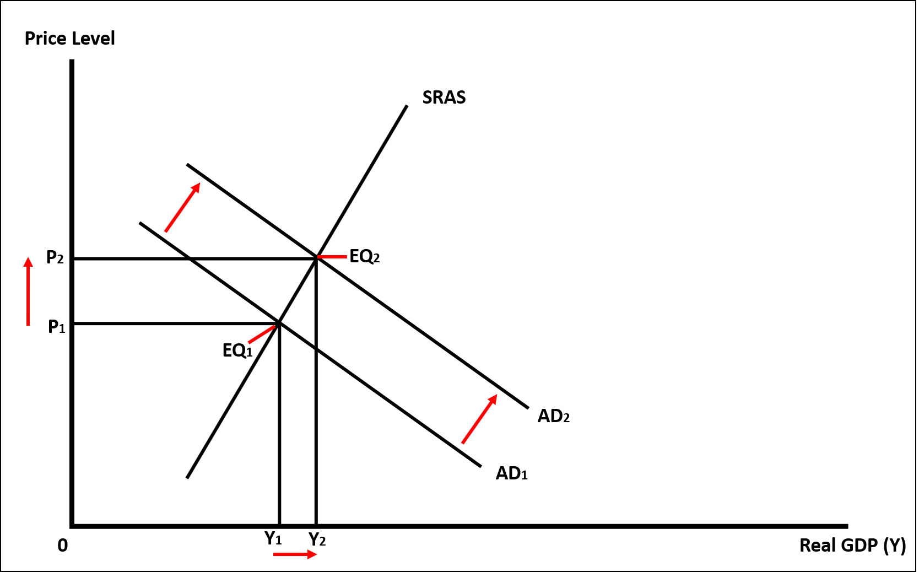
Moreover, in figure 1 it can also be seen that when the aggregate demand (in the short-run) is increased from Y1 to Y2, this has caused the price to move from P1 to P2, which is also indicated by the movement along the supply curve. The overall impact of this increase in aggregate demand also caused the equilibrium point to shift from EQ1 to EQ2. However, as indicated by the graph, since the price was sticky in the short run, this made the supply curve more inelastic. In other words, when demand was shifted from AD1 to AD2, the increase in price from P1 to P2 was higher than the increase in output from Y1 to Y2. Again, the inelastic supply curve in the short run can be explained by the concept of sticky prices which suggest that the wages of labour or prices of raw materials/inputs in the short run usually remain less flexible or unalterable (Carvalho et al., 2021). This, as a result, completely reduces the ability of the firms to control the cost of their factors of production in order to respond to the sudden changes under the aggregate demand that is observed in a given economy, making the aggregate supply curve inelastic.
Figure 1: Short-run Equilibrium in Aggregate Demand and Supply Curves (Sticky Prices)

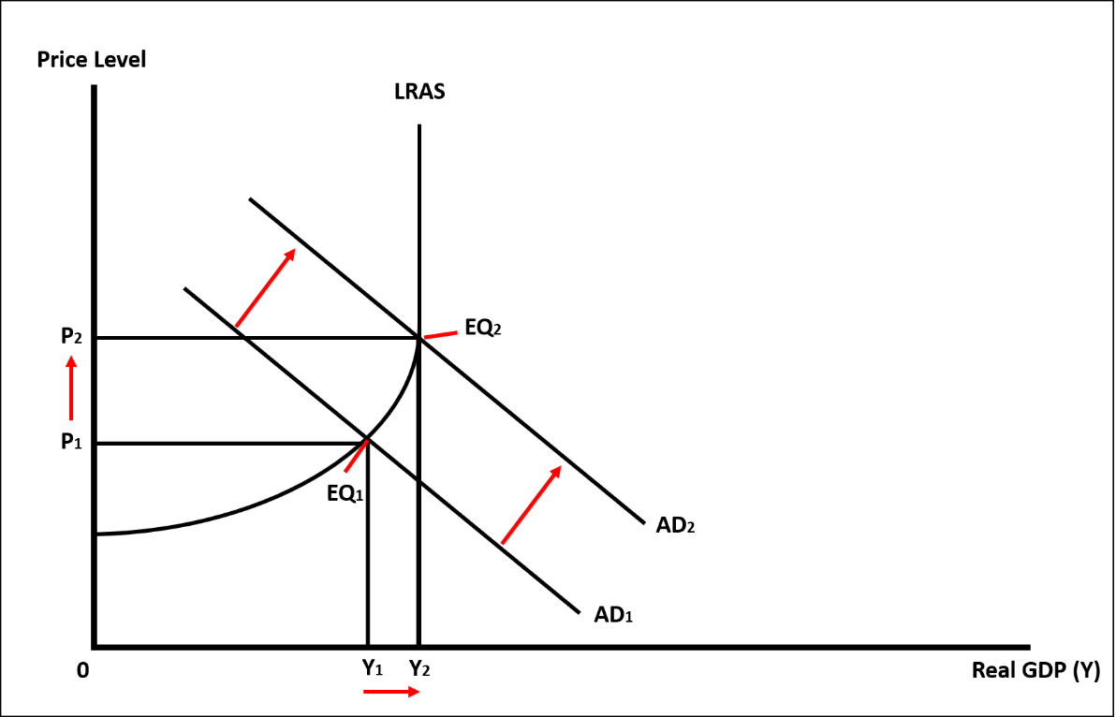
Answer 1 (Surnames M-Z)
Figure 2: Long-run Equilibrium in Aggregate Demand and Supply Curves (Flexible Prices)
In figure 2, the aggregate demand and supply curve is again provided but it is now indicating or explaining the long-run equilibrium in an economy where the price level is usually found to become flexible. In macroeconomics, the concept of long-run typically represents a period where the firms are able to gain sufficient time to adjust their inputs in response to the changes in aggregate demand (Skott, 2016). This is also considered as a period where the firms are able to renegotiate wages of their labour, increase or reduce their workforce, and alter the level of production of their products and services by purchasing (or selling off) their land, machinery, or capital. Moreover, the long run is also considered as a period where all the cost of inputs becomes variable for firms (Rao, 2016).
From figure 2, it can be seen that in the long-run, when aggregate demand is increased within a given economy from AD1 to AD2, again a movement along the supply curve can be observed, which is not only causing the prices of products and services to increase from P1 to P2, but the output or real GDP is also increasing from Y1 to Y1, making a new equilibrium point at EQ2. However, unlike the short-run aggregate supply curve, the long-run aggregate supply curve is initially found to be horizontal but then it gradually becomes vertical when the output or real GDP is increased (Seeley, 2017).
This this regard, the vertical line of LRAS is indicating a full employment level in an economy, which means that at Y2, the output in an economy will no longer increase further no matter what the price the people might be willing to pay in order to purchase the goods and services. In other words, the supply curve is becoming perfectly inelastic. However, the long-run aggregate supply curve can shift rightward, if the productivity of an economy experiences an increase by either having an improvement under the quality of resources or an increase within the quantity/number of scarce resources (or both) (Beenstock, 2020). This will also shift the production possibility curve outward, and the new equilibrium price (EQ3) within the figure provided above, will equate the aggregate demand and supply at an increased output (Y3). This effect of increased LRAS has also been shown in figure 3.
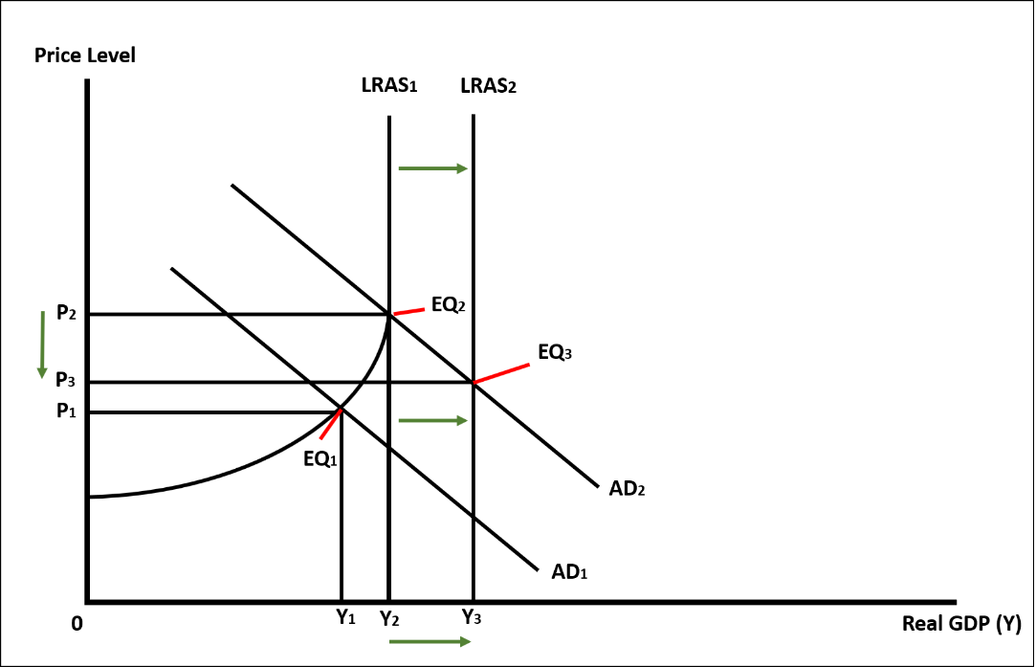

Figure 3: Shift in LRAS

Answer 2 (i)
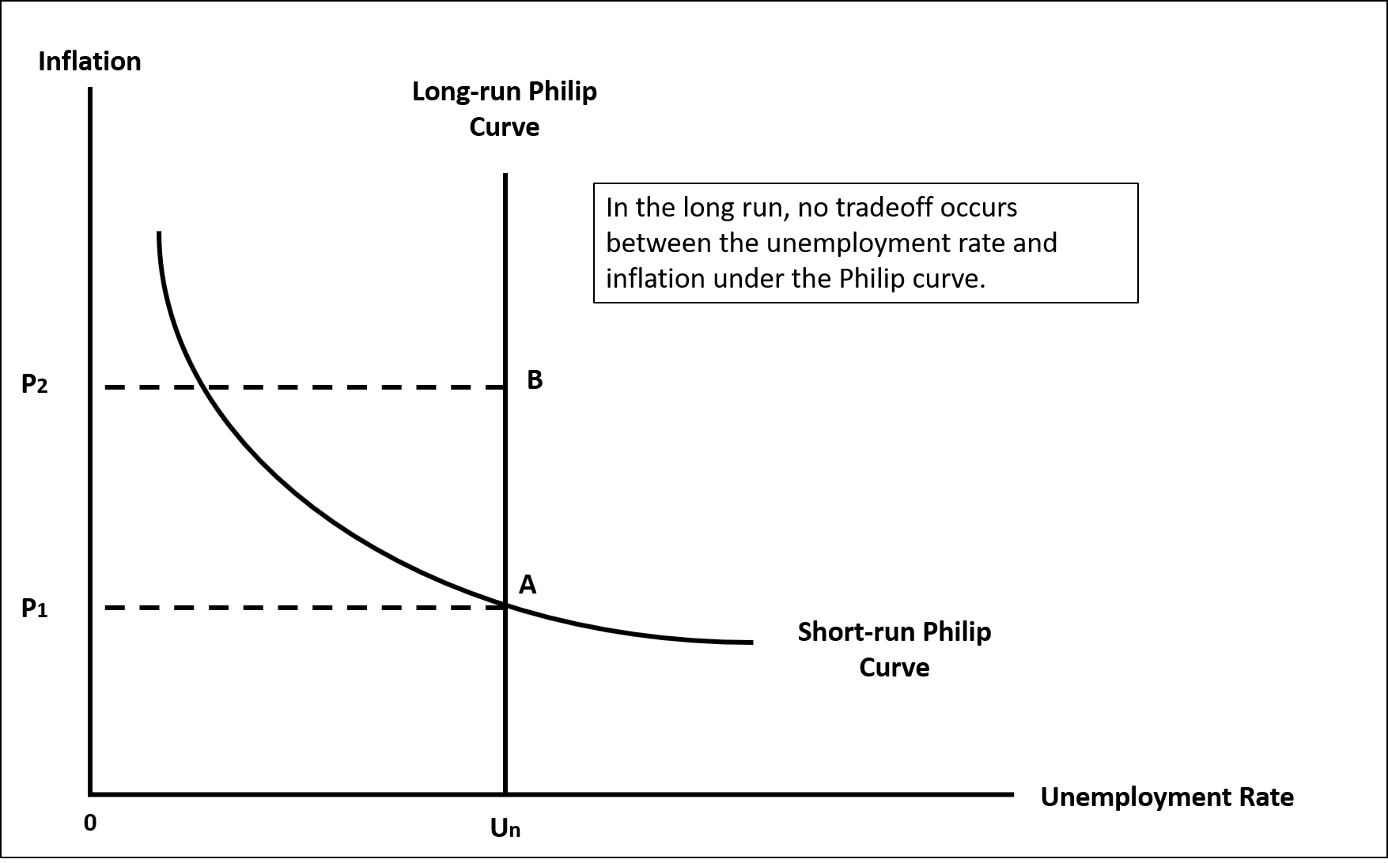
Figure 4: Long-run Equilibrium – Philips Curve Diagram

Answer 2 (ii)

Equation of Philips Curve
π = π^{e} − h (U − U_{N}), h > 0
Where: π = Inflation
U = Unemployment
π^{e} = Expected Inflation
h = Fixed Positive Coefficient
U_{N} = Natural Rate of Unemployment

Answer 3 (a) (Surnames A-F)
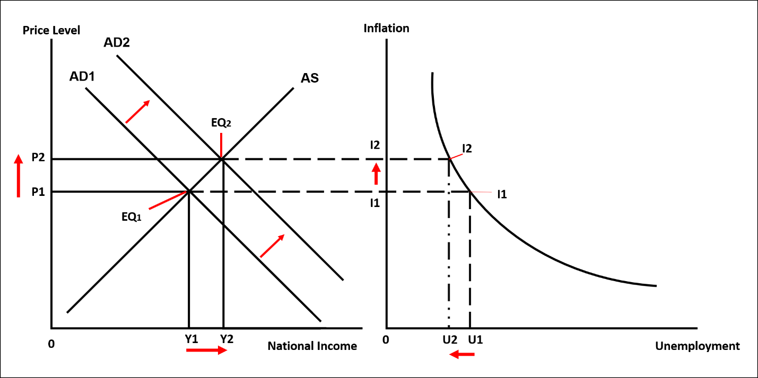
For this question, it has been assumed that the policy change within the economy has occurred in the form of expansionary fiscal policy. While using this policy, the government typically focuses on expanding the supply of money within the economy by utilising the budgetary tools related to either reducing the tax rate or increasing spending (or both) (Chugunov and Pasichnyi, 2018). This, in turn, provides both the businesses and consumers more money that assist them to increase their spending.
Figure 5: Short-run Effect of Policy Change on AS/AD diagram and Philips Curve
As can be viewed from the above figure, the short-run aggregate supply and demand curves have been provided that are initially equating at an equilibrium point EQ1. Moreover, at this equilibrium point, the unemployment level in the economy is at U1 while the inflation rate is at I1 (which is also indicated or reflected by P1 at AS/AD graph on the right-hand side of the figure). However, assuming that the government has now enacted and used an expansionary fiscal policy, this has shifted the aggregate demand curve in figure 5 from AD1 to AD2. The national income or the output in the economy has also increased from Y1 to Y2 and a movement along the aggregate supply curve can also be observed after the increase within the prices of goods and services from P1 to P2. The resulting impact of these changes caused by expansionary fiscal policy has now equated the aggregate supply and demand curve at EQ2.
However, these changes have also increased the inflation rate in the economy since the supply of products, including raw materials, land, capital, and labour in the short run tends to remain fixed. In other words, it would take time for the producers or suppliers to increase the supply of their products by hiring more employees, purchasing more lands to build more factories, and buying new machinery, etc (Del Negro et al., 2020). Thus, in the short run, the suppliers will try to address this increased in aggregate demand caused by expansionary fiscal policy, by raising the prices of their goods and services.
Moreover, they will also try to hire more employees to address this aggregate demand, which will help in reducing the unemployment rate in the economy. However, the unemployment rate will not be decreased significantly because the Philips curve will become more inelastic at a higher inflation rate. This decrease in the unemployment rate has also been shown under the Philips curve which is provided on the right-hand side of figure 5. Thus, the economy will experience trade off in the short-run in terms of experiencing a decrease within the unemployment rate, but an increase under the inflation rate due to increased demand for goods and services in the economy (Ball and Mazumder, 2019).

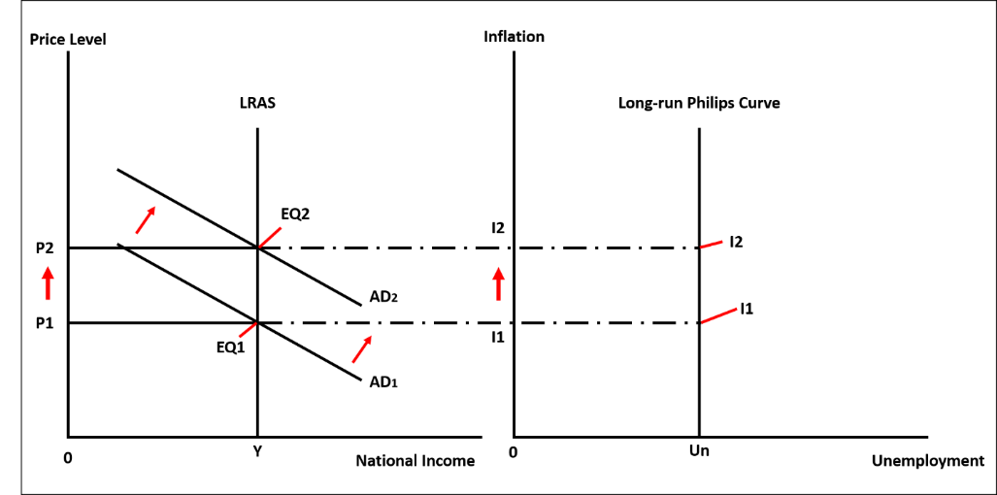
Answer 3 (b) (Surnames A-F)

Figure 6: Long-run Effect of Policy Change on AS/AD diagram and Philips Curve
In figure 6, the long-run effect of expansionary fiscal policy has been provided where it can be seen in the AS/AD diagram on the left-hand side of the figure that when the government decided to cut taxes and increase spending, this, as a result, shifted the aggregate demand in the economy rightward from AD1 to AD2. However, and as stated earlier, in the long run, the aggregate supply curve usually becomes perfectly inelastic (unless the quality and quantity of the resources are improved) indicating an economic situation where a full-employment level is reached (Bekaert et al., 2021). Moreover, this curve also indicates that the resources have now reached their full capacity and they can no longer increase in order to increase the production of goods and services.
Thus, the resulting impact of the expansionary fiscal policy in the graph indicates that the price of goods and services has increased in the economy from P1 to P2, but the output/national income has remained the same. Since the prices have increased in the economy, this has also increased the inflation rate from I1 to I2 which can also be seen in the Philips curve provided on the right-hand side of figure 6. However, as the economy has reached a full employment level, the Philips curve has also become perfectly inelastic at Un.
This is also indicating that the level of employment cannot be increased further, causing a shortage of labour to meet the high aggregate demand for the products and services in the economy. This will also increase the cost of labour for firms as the existing employees will demand higher wages in order to provide their services for producing an increased quantity of goods and services (Hawkins, 2017). The resulting impact of these high costs (i.e., increased wages) will again be realised in the economy in the form of cost-push inflation, forcing the firms to charge high prices for their goods and services in order to meet their cost of production (Schwarzer, 2018).

References
Ball, L. and Mazumder, S., 2019. A Phillips Curve with anchored expectations and short‐term unemployment. Journal of Money, Credit and Banking, 51(1), pp.111-137.
Beenstock, M., 2020. Aggregate supply in spatial general equilibrium theory. Spatial Economic Analysis, 15(4), pp.374-391.
Bekaert, G., Engstrom, E. and Ermolov, A., 2021. Uncertainty and the Economy: The Evolving Distributions of Aggregate Supply and Demand Shocks. Available at SSRN 3765164.
Carvalho, C., Lee, J.W. and Park, W.Y., 2021. Sectoral price facts in a sticky-price model. American Economic Journal: Macroeconomics, 13(1), pp.216-56.
Chugunov, I.Y. and Pasichnyi, M.D., 2018. Fiscal policy for economic development. Scientific bulletin of Polissia, 1(1 (13)), pp.54-61.
Del Negro, M., Lenza, M., Primiceri, G.E. and Tambalotti, A., 2020. What’s up with the Phillips Curve? (No. w27003). National Bureau of Economic Research.
Eggertsson, G.B. and Garga, V., 2019. Sticky prices versus sticky information: Does it matter for policy paradoxes?. Review of Economic Dynamics, 31, pp.363-392.
Hawkins, R.J., 2017. Macroeconomic susceptibility, inflation, and aggregate supply. Physica A: Statistical Mechanics and its Applications, 469, pp.15-22.
Rao, B.B. ed., 2016. Aggregate demand and supply: A critique of orthodox macroeconomic modelling. Springer.
Schwarzer, J.A., 2018. Retrospectives: Cost-Push and Demand-Pull Inflation: Milton Friedman and the" Cruel Dilemma". Journal of economic perspectives, 32(1), pp.195-210.
Seeley, K., 2017. Short-Run Aggregate Supply/Aggregate Demand and Policy. In Macroeconomics in Ecological Context (pp. 273-294). Springer, Cham.
Skott, P., 2016. Aggregate demand, functional finance, and secular stagnation. European Journal of Economics and Economic Policies: Intervention, 13(2), pp.172-188.

